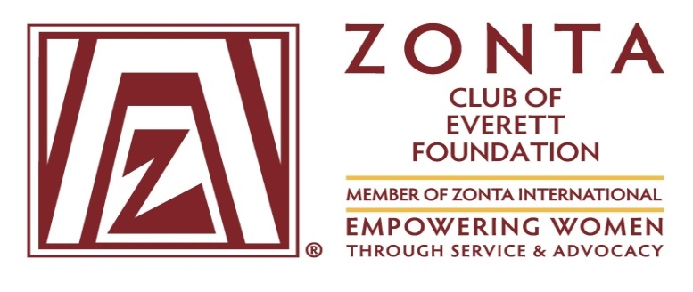

**The Zonta Club of Everett Foundation**

P**resents the acclaimed documentary play**

**SEVEN**

A collaboration by seven award-winning female playwrights, the play is based on personal interviews with seven extraordinary women in the Vital Voices Global Leadership Network who triumphed over enormous obstacles to bring about major changes in their home countries of Russia, Pakistan, Nigeria, Northern Ireland, Afghanistan, Guatemala, and Cambodia.

**June 17, 2016 7:30 p.m.**

PUD Auditorium

2320 California Street, Everett

**Featuring Guest Readers:**

***Sutapa Basu, Honorable Janice Ellis, Dr. Jean Hernandez***

***Pam LeSesne, Dr. Suzanne Poppema, Rita Zawaideh and Sierra Zweig***

**Tickets:**

**https://www.eventbrite.com/e/zonta-club-of-everett-foundation-presents-seven-tickets-24873348856**